PROJECT REPORT OF CO-OP Project at Industry (Module-2)
ON
Comparison between Deep Learning Models for Early Detection of Alzheimer’s Disease
submitted in partial fulfilment of the requirements for the award of degree of

BACHELOR OF ENGINEERING
In
COMPUTER SCIENCE AND ENGINEERING

Submitted by: Supervised By:
Aastha Lalit Sharma
2210991129 Assistant Professor
Chitkara University


DEPARTMENT OF COMPUTER SCIENCE AND ENGINEERING

CHITKARA UNIVERSITY INSTITUTE OF ENGINEERING AND TECHNOLOGY
CHITKARA UNIVERSITY, PUNJAB, INDIA

CONTENTS

S.No. | Title | Page No.
 | Acknowledgement | iv
 | List of Figures and Tables | v
 | Abstract
1 | Introduction | 1
2 | Methodology
3 | Tools and Technologies
4 | Implementation
5 | Major Findings/Outcomes/Output/Results
6 | Conclusion and Future Scope
 | References

DECLARATION

I hereby certify that the work which is being presented in the project report entitled “Comparison Between Deep Learning Models for Early detection of Alzheimer’s Disease” in partial fulfilment of requirement for the award of the degree of Bachelor of Engineering (Computer Science and Engineering) submitted in the department of Computer Science and Engineering at Chitkara University Institute of Engineering and Technology, Chitkara University, Punjab, India, is an authentic record of my own work carried out under the supervision of Lalit Sharma. The matter presented in this project report has not been submitted in any other university/institute for the award of any degree.

Place: Rajpura (Name of the Student)
Date: 3 May 2026 (University Roll No. 2210991129)

This is to certify that the above statement made by the candidate is correct to the best of my knowledge and belief.

Lalit Sharma
Assistant Professor
Department of Computer Science and Engineering
Chitkara University Institute of Engineering and Technology,
Chitkara University, Punjab, India

ACKNOWLEDGEMENT

I would like to express my sincere gratitude to my mentor, Dr. Lalit K. Sharma, Assistant Professor, Department of Computer Science & Engineering, Chitkara University, for his invaluable guidance, constant support, and insightful suggestions throughout the course of this research work. His mentorship played a crucial role in shaping this project and enhancing its quality.

I would also like to thank the Department of Computer Science & Engineering at Chitkara University for providing the necessary resources and a conducive academic environment to successfully carry out this research.

I extend my appreciation to the creators of the Kaggle OASIS Alzheimer’s MRI dataset for making such valuable data publicly available, which significantly contributed to this study.

I am also grateful to the developers of open-source tools and frameworks such as TensorFlow, Keras, and Google Colab, which enabled efficient implementation and experimentation.

Finally, I would like to thank my family and friends for their continuous encouragement, motivation, and support throughout this journey.

Abstract
Alzheimer’s Disease (AD) is a progressive neurological disorder that leads to memory loss, cognitive decline, and behavioral impairment. Early diagnosis plays a crucial role in slowing disease progression and improving patient care. This research presents a deep learning-based framework for multi-class classification of Alzheimer’s Disease stages using MRI brain images.
A comparative analysis was conducted using four models: a baseline Convolutional Neural Network (CNN), EfficientNetB0, DenseNet, and a proposed enhanced DenseNet model. The proposed model integrates focal loss to address class imbalance, Test Time Augmentation (TTA) to improve prediction robustness, and Grad-CAM to provide interpretability.
The models were trained and evaluated on the Kaggle OASIS Alzheimer’s MRI dataset using Google Colab with NVIDIA T4 GPU acceleration. Experimental results indicate that the proposed DenseNet model outperforms other models, achieving a balanced accuracy of 94%. The results demonstrate improved classification performance, especially for minority classes, and highlight the potential of advanced deep learning techniques in assisting early diagnosis of Alzheimer’s Disease.

- Introduction
Alzheimer’s Disease is one of the most common forms of dementia, primarily affecting the elderly population. It leads to progressive deterioration in memory, thinking ability, and behavior, ultimately impacting daily functioning. With the global increase in aging populations, Alzheimer’s Disease has become a major healthcare concern.

Magnetic Resonance Imaging (MRI) is widely used for detecting structural changes in the brain associated with Alzheimer’s Disease. However, manual analysis of MRI scans is time-consuming, subjective, and dependent on expert knowledge. Automated systems based on Artificial Intelligence can assist clinicians by providing faster and more accurate diagnoses.

Deep Learning, particularly Convolutional Neural Networks (CNNs), has shown remarkable success in image classification tasks. CNNs can automatically extract relevant features from images, making them highly suitable for medical imaging applications.

Despite these advancements, challenges such as class imbalance, subtle differences between disease stages, and limited dataset size still affect model performance. This research aims to address these challenges by implementing and comparing multiple CNN-based models and proposing an enhanced DenseNet model with improved performance and interpretability.
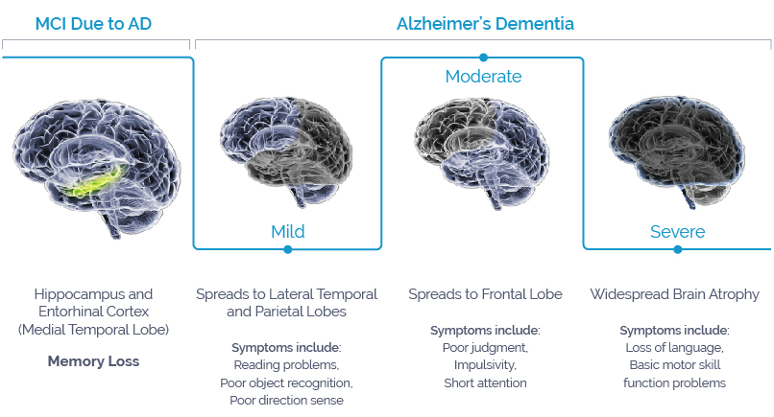

- Methodology
2.1 Dataset Description
The dataset used in this research is the OASIS Alzheimer’s MRI dataset obtained from Kaggle. It consists of brain MRI images categorized into four classes: Non-Demented, Very Mild Demented, Mild Demented, and Moderate Demented.

The dataset is imbalanced, with a significantly higher number of Non-Demented images compared to other classes. This imbalance poses a challenge for classification models, particularly in correctly identifying minority classes.
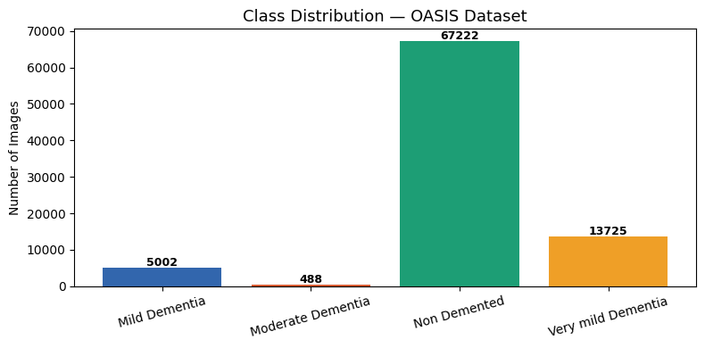
2.2 Data Preprocessing
To ensure consistency and improve model performance, several preprocessing steps were applied. All images were resized to 224×224 pixels to match the input size required by the models. Pixel values were normalized to the range [0,1] to facilitate efficient training.

Data augmentation techniques such as rotation, horizontal flipping, zooming, and shifting were applied to artificially increase the size of the dataset and reduce overfitting. These transformations help the model generalize better to unseen data.
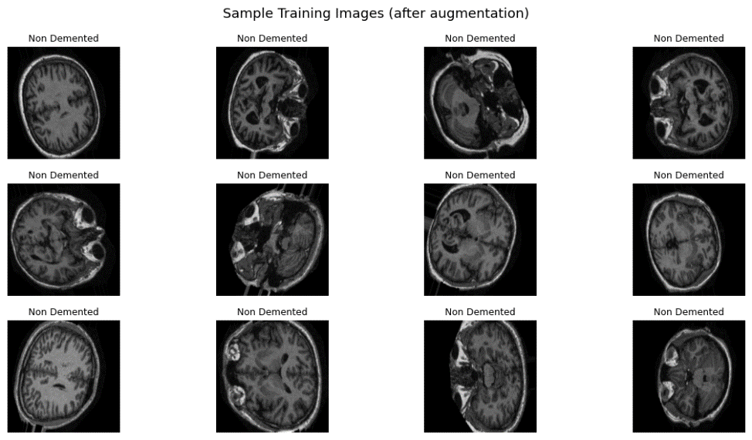
2.3 Model Architectures
- Baseline CNN
  - A baseline Convolutional Neural Network was implemented as a reference model. It consists of multiple convolutional layers followed by ReLU activation and max-pooling layers. Fully connected layers were used for classification.

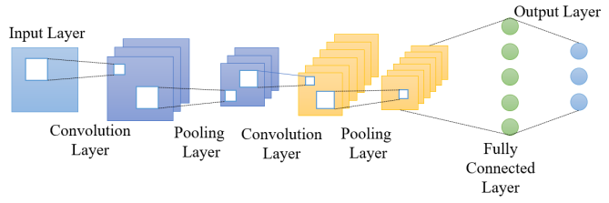

- EfficientNetB0
  - EfficientNetB0 is a pretrained deep learning model that uses compound scaling to balance depth, width, and resolution. Transfer learning was applied by fine-tuning the model on the MRI dataset, enabling improved performance and faster convergence.

- DenseNet
  - DenseNet introduces dense connections between layers, allowing each layer to receive inputs from all previous layers. This architecture improves feature reuse, reduces redundancy, and mitigates the vanishing gradient problem.
- Proposed DenseNet Model
  - The proposed model enhances DenseNet by incorporating advanced techniques to improve performance and robustness.
  - Focal Loss was used instead of standard cross-entropy loss to handle class imbalance. It assigns higher importance to difficult samples, enabling better learning for minority classes.
  - Test Time Augmentation (TTA) was applied during inference, where multiple augmented versions of each test image were generated and predictions were averaged. This improves prediction stability and robustness.
  - Grad-CAM was used to visualize the regions of interest in MRI images, providing interpretability and helping understand model decision
2.4 Training Configuration
The models were trained using the Adam optimizer with an appropriate learning rate. A suitable batch size was selected based on GPU memory constraints. Training was performed for multiple epochs, and validation performance was monitored to prevent overfitting.
2.5 Evaluation Metrics
Model performance was evaluated using Accuracy, Precision, Recall, F1-score, and Balanced Accuracy. Balanced Accuracy was particularly important due to class imbalance. Confusion matrices were used to analyze class-wise prediction performance.
Accuracy = (TP + TN) / (TP + TN + FP + FN) (2)
Precision = TP / (TP + FP) (3)
Recall = TP / (TP + FN) (4)
F1-Score = 2 × (Precision × Recall) / (Precision + Recall) (5)

- Tools and Technologies
The implementation of this research was carried out using Python. Deep learning models were developed using TensorFlow and Keras libraries. NumPy and Pandas were used for data handling, while Matplotlib and Seaborn were used for visualization.

Google Colab was used as the development platform, providing access to NVIDIA T4 GPU for faster training and experimentation. The dataset was sourced from Kaggle.
- Implementation
4.1 Data Pipeline
The dataset was loaded and divided into training, validation, and testing sets. Proper shuffling and batching techniques were applied to ensure efficient data handling during training.
4.2 Model Training
Each model was trained on the processed dataset using the defined training configuration. Training and validation accuracy were monitored over epochs to evaluate model learning behavior.
4.3 Prediction and Evaluation
After training, the models were evaluated on the test dataset. Predictions were generated and compared with actual labels to compute performance metrics.

Test Time Augmentation was applied to enhance prediction accuracy. Confusion matrices were generated to visualize classification performance across different classes.

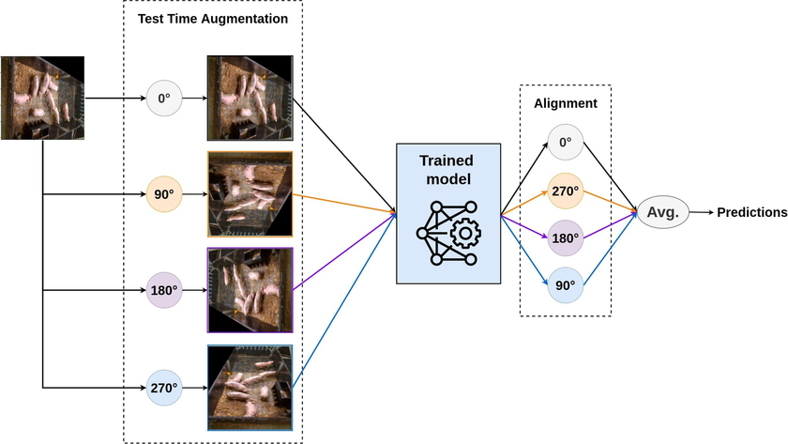

- Major Findings / Results
5.1 Model Comparison
The performance of all models was compared using multiple evaluation metrics.

Model | Accuracy (%) | Macro Precision | Macro Recall | Macro F1-Score | Balanced Accuracy
Baseline CNN | 16 | 0.04 | 0.25 | 0.07 | 0.25
EfficientNet-B0 | 78 | 0.19 | 0.25 | 0.22 | 0.25
DenseNet121 (Initial) | 73 | 0.68 | 0.62 | 0.55 | 0.63
DenseNet121 (Proposed) | 85 | 0.79 | 0.94 | 0.84 | 0.94

5.2 Confusion Matrix Analysis

Confusion matrices were analyzed to understand the classification performance of each model. The baseline CNN showed poor performance in minority classes. EfficientNetB0 improved overall accuracy but still struggled with imbalance. DenseNet performed better due to feature reuse and improved gradient flow.

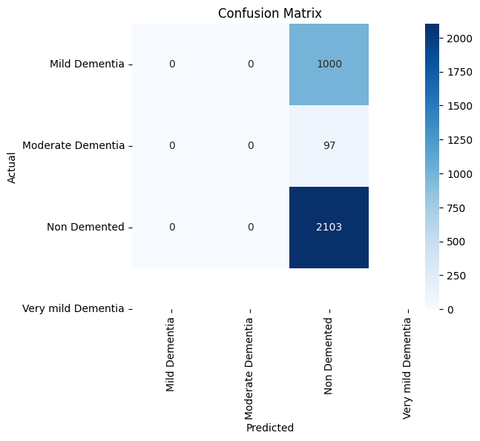

Confusion Matrix – EfficientNetB0
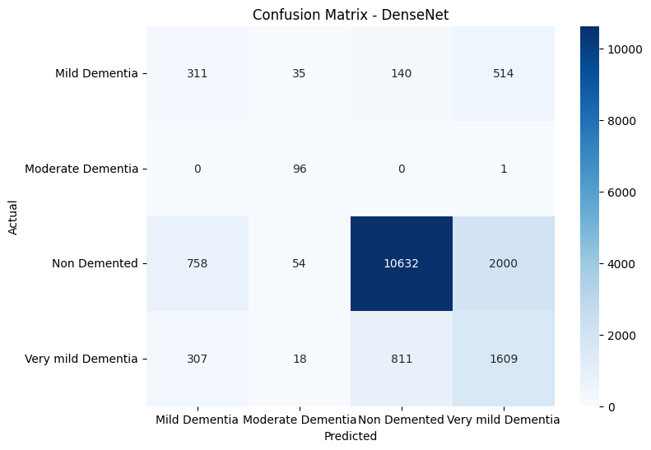

Confusion Matrix – DenseNet

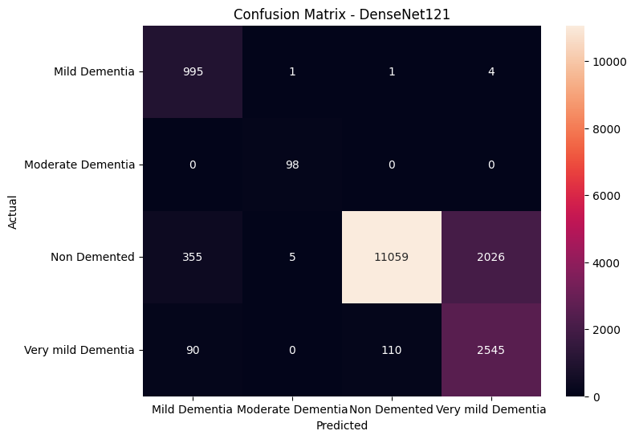
Confusion Matrix – Proposed DenseNet
5.3 Key Observations

The baseline CNN struggled with class imbalance and failed to correctly classify minority classes. EfficientNetB0 improved performance due to transfer learning but still faced imbalance issues. DenseNet provided better results due to its architecture.

The proposed DenseNet model achieved the best performance by effectively addressing class imbalance using focal loss and improving prediction robustness through TTA. It significantly reduced false negatives, which is critical in medical diagnosis.

5.4 Final Results

The proposed DenseNet model achieved a balanced accuracy of 94%, outperforming all other models. The integration of focal loss allowed the model to focus on difficult samples, while TTA improved prediction consistency.

- Conclusion and Future Scope
6.1 Conclusion
This research demonstrated the effectiveness of CNN-based models in detecting Alzheimer’s Disease using MRI images. Among all models, the proposed DenseNet model achieved the best performance due to the integration of focal loss, Test Time Augmentation, and Grad-CAM.

The model successfully addressed class imbalance and improved classification accuracy, making it a reliable tool for assisting early diagnosis. The use of Grad-CAM further enhanced interpretability, providing insights into model decisions.
6.2 Future Scope
Future work can focus on using larger and more diverse datasets to improve generalization. The model can be deployed in real-world healthcare systems for assisting clinicians. Further research can explore hybrid deep learning models and multimodal data integration.
- References
- J. Chen, Y. Hong, and O. Weiner, “A comparative study of CNN models in Alzheimer’s detection,” Stanford University, CS231n Course Project, 2024. [Online]. Available: https://cs231n.stanford.edu/2024/papers/a-comparative-study-of-cnn-models-in-alzheimers-detection.pdf
- R. R. Janghel and Y. K. Rathore, “Deep convolution neural network based system for early diagnosis of Alzheimer's disease,” IRBM, vol. 42, no. 4, pp. 258–267, 2021, doi: 10.1016/j.irbm.2020.06.006.
- Krizhevsky, I. Sutskever, and G. E. Hinton, “ImageNet classification with deep convolutional neural networks,” arXiv preprint arXiv:1603.08631, 2016. doi: 10.48550/arXiv.1603.08631.
- A. Mehmood, A. Abugabah, A. A. AlZubi, and L. Sanzogni, “Early diagnosis of Alzheimer’s disease based on convolutional neural networks,” Comput. Syst. Sci. Eng., vol. 43, no. 1, pp. 305–315, 2022, doi: 10.32604/csse.2022.018520.
- K. Oh, Y. C. Chung, K. W. Kim, W. S. Kim, and I. S. Oh, “Classification and visualization of Alzheimer’s disease using volumetric convolutional neural network and transfer learning,” Scientific Reports, vol. 9, no. 1, p. 18150, Dec. 2019, doi: 10.1038/s41598-019-54548-6.
- Mehmood A, Maqsood M, Bashir M, Shuyuan Y. A Deep Siamese Convolution Neural Network for Multi-Class Classification of Alzheimer Disease. Brain Sci. 2020 Feb 5;10(2):84. doi: 10.3390/brainsci10020084. PMID: 32033462; PMCID: PMC7071616.
- W. Al Shehri, “Alzheimer's disease diagnosis and classification using deep learning techniques,” PeerJ Computer Science, vol. 8, p. e1177, Dec. 2022, doi: 10.7717/peerj-cs.1177.
- S. Sharma, K. Guleria, S. Tiwari, and S. Kumar, “A deep learning based convolutional neural network model with VGG16 feature extractor for the detection of Alzheimer disease using MRI scans,” Measurement: Sensors, vol. 24, p. 100506, 2022, doi: 10.1016/j.measen.2022.100506.
- A. A., M. P., M. Hamdi, S. Bourouis, R. K., and F. Mohmed, “Evaluation of neuro images for the diagnosis of Alzheimer's disease using deep learning neural network,” Frontiers in Public Health, vol. 10, p. 834032, 2022, doi: 10.3389/fpubh.2022.834032.
- M. Avşar and K. Polat, “Classifying Alzheimer's disease based on a convolutional neural network with MRI images,” Journal of Artificial Intelligence and Systems, vol. 5, pp. 46–57, 2023, doi: 10.33969/AIS.2023050104.
- S. Bringas, S. Salomón, R. Duque, J. L. Montaña, and C. Lage, “A convolutional neural network-based method for human movement patterns classification in Alzheimer’s disease,” Proceedings, vol. 31, no. 1, p. 72, 2019, doi: 10.3390/proceedings2019031072.
- N. Ujilast, N. Firdausita, C. Aditya, and Y. Azhar, “MRI image based Alzheimer’s disease classification using convolutional neural network: EfficientNet architecture,” Jurnal RESTI (Rekayasa Sistem dan Teknologi Informasi), vol. 8, pp. 18–25, 2024, doi: 10.29207/resti.v8i1.5457.
- D. Komolovaitė, R. Maskeliūnas, and R. Damaševičius, “Deep convolutional neural network-based visual stimuli classification using electroencephalography signals of healthy and Alzheimer’s disease subjects,” Life, vol. 12, no. 3, p. 374, 2022, doi: 10.3390/life12030374.
- W. Lin, T. Tong, Q. Gao, D. Guo, X. Du, Y. Yang, G. Guo, M. Xiao, M. Du, and X. Qu, “Convolutional neural networks-based MRI image analysis for the Alzheimer's disease prediction from mild cognitive impairment,” Frontiers in Neuroscience, vol. 12, p. 777, Nov. 2018, doi: 10.3389/fnins.2018.00777.
- S. Basheera and M. S. S. Ram, “Convolution neural network–based Alzheimer's disease classification using hybrid enhanced independent component analysis based segmented gray matter of T2 weighted magnetic resonance imaging with clinical valuation,” Alzheimer's & Dementia: Translational Research & Clinical Interventions, vol. 5, pp. 974–986, 2019, doi: 10.1016/j.trci.2019.10.001.
- M. Z. Hussain, T. Shahzad, S. Mehmood, K. Akram, M. A. Khan, M. U. Tariq, and A. Ahmed, “A fine-tuned convolutional neural network model for accurate Alzheimer's disease classification,” Scientific Reports, vol. 15, no. 1, p. 11616, Apr. 2025, doi: 10.1038/s41598-025-86635-2.
- H. Ji, Z. Liu, W. Q. Yan, and R. Klette, “Early diagnosis of Alzheimer's disease using deep learning,” in Proc. 2nd Int. Conf. Control Comput. Vis. (ICCCV), Jeju, Republic of Korea, 2019, pp. 87–91, doi: 10.1145/3341016.3341024.
- H. Ji, Z. Liu, W. Q. Yan, and R. Klette, “Early diagnosis of Alzheimer's disease using deep learning,” in Proc. 2nd Int. Conf. Control Comput. Vis. (ICCCV), Jeju, Republic of Korea, 2019, pp. 87–91, doi: 10.1145/3341016.3341024.
- R. A. Hazarika, A. K. Maji, D. Kandar, E. Jasinska, P. Krejci, Z. Leonowicz, and M. Jasinski, “An approach for classification of Alzheimer’s disease using deep neural network and brain magnetic resonance imaging (MRI),” Electronics, vol. 12, no. 3, p. 676, 2023, doi: 10.3390/electronics12030676.
- S. Dardouri, “An efficient method for early Alzheimer’s disease detection based on MRI images using deep convolutional neural networks,” Frontiers in Artificial Intelligence, vol. 8, p. 1563016, 2025, doi: 10.3389/frai.2025.1563016.
- F. Mohamed, “Early diagnosis of Alzheimer's disease using convolutional neural network-based MRI,” Malaysian Journal of Fundamental and Applied Sciences, 2023, doi: 10.11113/MJFAS.V19N3.2908.
- M. E. Hasan and A. Wagler, “New convolutional neural network and graph convolutional network-based architecture for AI applications in Alzheimer’s disease and dementia-stage classification,” AI, vol. 5, no. 1, pp. 342–363, 2024, doi: 10.3390/ai5010017.
- Z. Sh. Aaraji and H. H. Abbas, “Automatic classification of Alzheimer's disease using brain MRI data and deep convolutional neural networks,” arXiv preprint arXiv:2204.00068, 2022.
- D. Ganesh, M. Aparna, M. Royal, M. Vinay, M. Sai, H. Sri, and M. Kumar, “Implementation of convolutional neural networks for detection of Alzheimer’s disease,” 2023.
- S. Pallawi and D. K. Singh, “Review and analysis of deep neural network models for Alzheimer's disease classification using brain magnetic resonance imaging,” Cognitive Computation and Systems, vol. 5, no. 1, pp. 1–13, 2023, doi: 10.1049/ccs2.12072.
- W. H. Bangyal, N. U. Rehman, A. Nawaz, K. Nisar, A. A. A. Ibrahim, R. Shakir, and D. B. Rawat, “Constructing domain ontology for Alzheimer disease using deep learning based approach,” Electronics, vol. 11, no. 12, p. 1890, 2022, doi: 10.3390/electronics11121890.
- M. W. Oktavian, N. Yudistira, and A. Ridok, “Classification of Alzheimer's disease using the convolutional neural network (CNN) with transfer learning and weighted loss,” arXiv preprint arXiv:2207.01584, 2022.
- A. Payan and G. Montana, “Predicting Alzheimer's disease: a neuroimaging study with 3D convolutional neural networks,” arXiv preprint arXiv:1502.02506, 2015.
- S. Chen, J. Zhang, X. Wei, and Q. Zhang, “Alzheimer's disease classification using structural MRI based on convolutional neural networks,” in Proc. Int. Conf., pp. 7–13, 2020, doi: 10.1145/3440054.3440056.
- E. Altinkaya, K. Polat, and B. Barakli, “Detection of Alzheimer’s disease and dementia states based on deep learning from MRI images: A comprehensive review,” Journal of the Institute of Electronics and Computer, vol. 1, pp. 39–53, 2019, doi: 10.33969/JIEC.2019.11005.
- J. Islam and Y. Zhang, “A novel deep learning based multi-class classification method for Alzheimer’s disease detection using brain MRI data,” in Lecture Notes in Computer Science (LNCS), 2017, pp. 213–222, doi: 10.1007/978-3-319-70772-3_20.
- H. Wang, T. Feng, Z. Zhao, X. Bai, G. Han, J. Wang, Z. Dai, R. Wang, W. Zhao, F. Ren, and F. Gao, “Classification of Alzheimer's disease based on deep learning of brain structural and metabolic data,” Frontiers in Aging Neuroscience, vol. 14, p. 927217, Jul. 2022, doi: 10.3389/fnagi.2022.927217.
- H. Chen, Q. Huang, S. Zhang, K. Hu, W. Xiong, L. Xiao, R. Cong, Q. Liu, and Z. Wang, “The Chinese herbal formula PAPZ ameliorates behavioral abnormalities in depressive mice,” Nutrients, vol. 11, no. 4, p. 859, Apr. 2019, doi: 10.3390/nu11040859.
- A. Hassan, A. Imran, A. U. Yasin, M. A. Waqas, and R. Fazal, “A multimodal approach for Alzheimer’s disease detection and classification using deep learning,” Journal of Computational and Biomedical Informatics (JCBI), vol. 6, no. 2, pp. 441–450, Mar. 2024.
- S. Muksimova, S. Umirzakova, N. Iskhakova, A. Khaitov, and Y. I. Cho, “Advanced convolutional neural network with attention mechanism for Alzheimer's disease classification using MRI,” Computers in Biology and Medicine, vol. 190, p. 110095, 2025, doi: 10.1016/j.compbiomed.2025.110095.
- S. E. Spasov, L. Passamonti, A. Duggento, P. Lio, and N. Toschi, “A multi-modal convolutional neural network framework for the prediction of Alzheimer's disease,” in Proc. Annu. Int. Conf. IEEE Eng. Med. Biol. Soc. (EMBC), 2018, pp. 1271–1274, doi: 10.1109/EMBC.2018.8512468.

